LEBANON COUNTY

BUREAU OF ELECTIONS & VOTER REGISTRATION

Robert J. Phillips

Michael Kuhn

Jo Ellen Litz

County Commissioners

Jamie Wolgemuth

County Administrator

David R. Warner, Jr.

County Solicitor

Sean D. Drasher

Director

E-mail: SDrasher@lebcnty.org

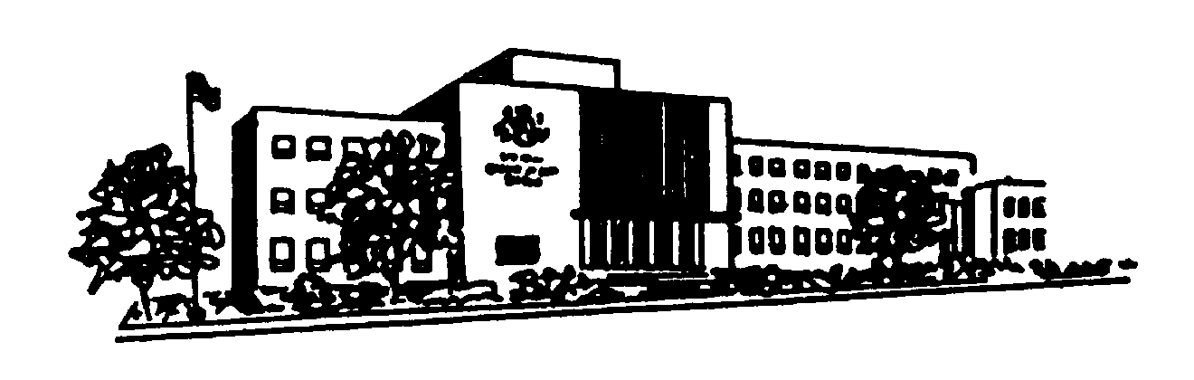

Suzanne Houser

Deputy

E-mail: SHouser@lebcnty.org

(717) 228-4428

Room 209, Municipal Building

400 South Eighth Street

Lebanon, PA 17042-6794

**PUBLIC NOTICE**

Notice is hereby given regarding the recount for the office of United States Senator ordered by Acting Secretary of State Leigh M Chapman at 8:30am on June 1st-2nd, 2022 at:

400 South 8th Street, Room 210

Lebanon, PA 17042-6794

All Election Day and Mail-In/Absentee ballots will be recounted at this location. As a part of this recount, a bipartisan team comprised of the Lebanon County Board of Elections and Director of Elections will adjudicate the ballots which represent ambiguous marks or other discrepancies.