Monday | Tuesday | Wednesday | Thursday | Friday
Meals must be ordered the day before 10:30AM. A donation of $4.50 would be appreciated. | 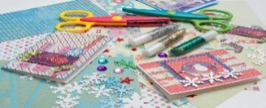 | 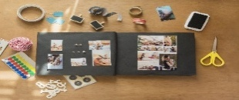 |  | Please let us know if you would like to  start another activity. Help us make our Center more fun!
3  10:00 Puzzles  10:30 Conversation Cafe  11:30 Lunch*  12:30 Pinochle | 4  10:00 Puzzles  10:30 Conversation Cafe  11:30 Lunch*  12:30 Card Games/Craft | 5  10:00 Puzzles  10:30 Conversation Café  11:30 Lunch*  12:30 Scrapbooking | 6  10:00 Puzzles  10:30 Conversation Café  12:30 Bingo | 7.  10:00 Puzzles  10:30 Chair Yoga  11:00 Lunch*  12:00 Lunch Bunch- Schwalm’s – Cleona
10  10:00 Puzzles  11:30 Lunch  12:30 St. Patrick’s Party- Wear Green | 11  10:00 Puzzles  10:30 Conversation Cafe  11:30 Lunch*  12:30 Card Games/Craft | 12  10:00 Puzzles  10:30 Conversation Café  11:30 Lunch*  12:30 Scrapbooking | 13.  10:00 Puzzles  10:30 Conversation Café  12:30 Bingo | 14.  10:00 Puzzles  10:30 Chair Yoga  11:30 Lunch*  12:00 Lunch Bunch – Cracker Barrel
17  10:00 Puzzles  11:30 Lunch*  12:30 Pinochle or Phase 10 | 18.  10:00 Puzzles  10:30 Conversation Cafe  11:30 Lunch*  12:30 Card Games/Craft | 19  10:00 Puzzles  11:30 Lunch*  12:30 Scrapbooking | 20.  10:00 Conversation Cafe  11:30 Lunch*  12:30 Prize Bingo | 21.  10:00 Puzzles  110:30 Chair Yoga  11:30 Lunch*  12:00 Lunch – Olive Garden
24.  10:00 Puzzles  11:30 Lunch  12:30 Cards | 25.  10:00 Puzzles  11:30 Lunch  12:30 Crafts with Rose/cards | 26.  10:00 Puzzles  11:30 Lunch  12:30 Scrapbooking | 27.  10:00 Puzzles  11:30 Lunch  12:30 Cards | 28  10.30 Chair Yoga  10:30 Conversation Café  11:00 Lunch*  12:00 Lunch Bunch – Hill Top Café – Lebanon County Career & Technology

