MYERSTOWN

SENIOR COMMUNITY CENTER

101 S. Railroad St

Myerstown, PA 17067

© 717-675-9546

Myerstown.SeniorCenter@lebanoncountypa.gov

## E:\County Logo.png

## 



**NEWSLETTER**

**MARCH 2025**

**Myerstown Senior Center is located at 101 S. Railroad St within the Myerstown Borough Hall on the 2nd floor and is open to all Lebanon County seniors 60 years of age and over.**

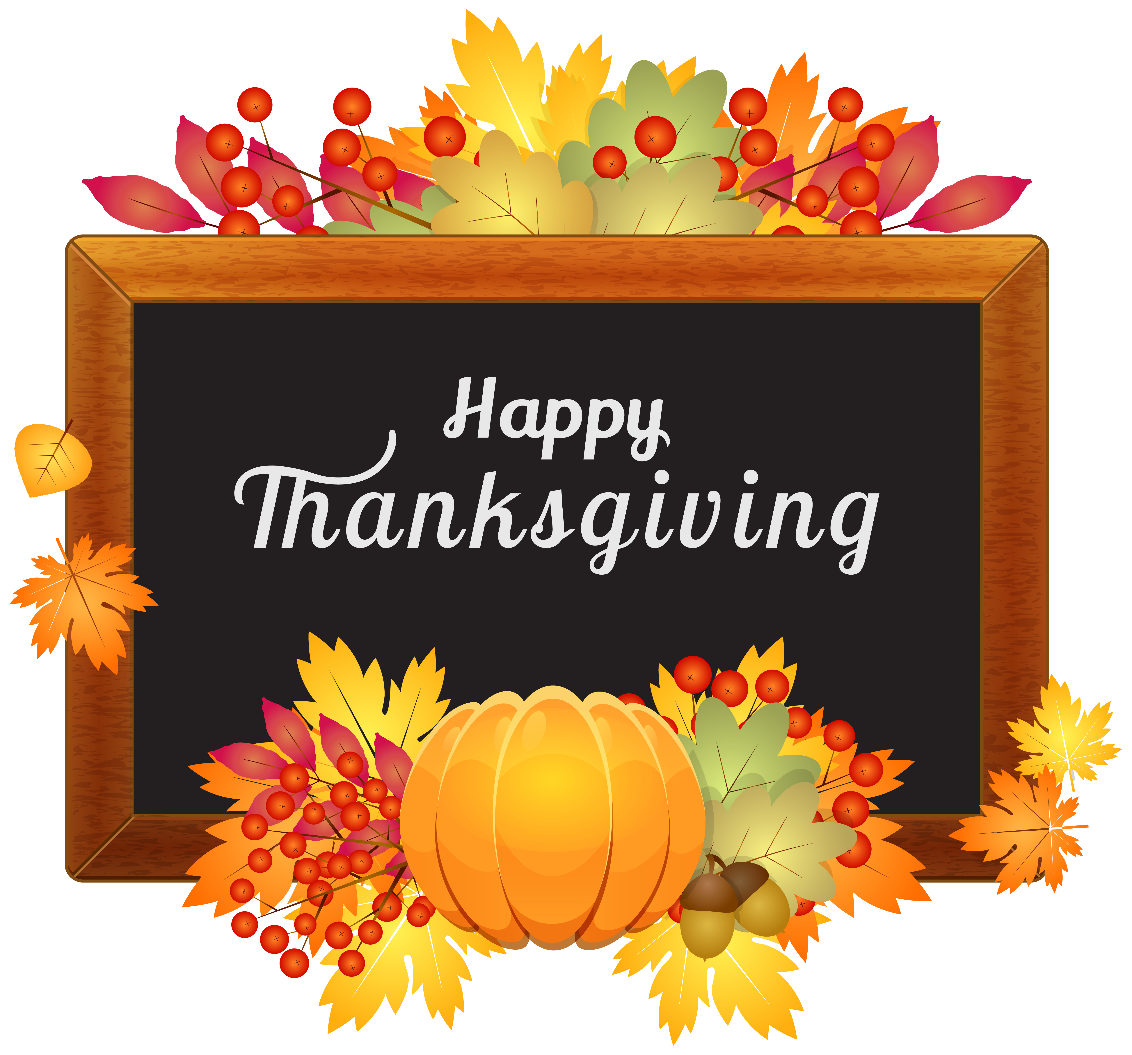

**We offer both on and off-site activities such as day trips, social events, exercise programs, consumer education, bingo and daily meals offered 5 days a week. Meal reservations need to be made by 11:00 AM on the previous business day. Suggested donation for meals is $4.50. No membership fee to join us. We are open weekdays from 10:00 AM to 2:00 PM**.

**COMMUNITY PHONE NUMBERS**

**Lebanon County Area Agency on Aging:**

**717-273-9262**

**Social Security Office: 1-800-772-1213**

**PACE-PACENET: 1-800-225-7223**

**Rent Rebate Office: 1-888-728-2937**

**Medicare: 1-800-633-4227**

**Anti-Fraud Hotline: 1-855-303-9470**

**TAX PREPARATION**

Call 717-644-9090. Leave a message with your name, phone number, preferred site (Myerstown, Lebanon, Jonestown) or search AARP site locator tool.

**NEW PROGRAM INFORMATION**

* **Open Gym Access for Walking**

8:30AM to 10:00AM daily,

8:30AM -2:00PM Wednesday & Friday

* **Pickleball**

**Tuesdays, 10:30AM – 12:30PM**

**Thursdays, 10:30AM - 12:30PM**

Beginners schedule available upon request

**SPECIAL PROGRAM INFORMATION**

* **Happy March Luncheon @ Country Fare\***

Wednesday, 3/5 @ 12:00 PM (Sign up by 2/26)

* **Bible Study**

**-**Tuesday 3/4 @ 1:00 PM with Pastor Keener

-Tuesday 3/18 with Pastor Bitner

* **Bingo* (new extended time)**

Fridays 10:30-11:45 AM, $3 to play for prizes

* **Spring Social & Pizza Lunch\***

Wednesday, 3/19 @ 11:00 AM

* **Soup & Sandwich Special Meal\***

Thursday,3/20. Order by 3/13.

**Menu**: NE Clam Chowder, Tomato Bisque, Tuna Salad Sandwich, Coleslaw, Lemon Meringue, Milk

Suggested Donation: $4.50

* **“Elder Fraud & Scams” Presented by FBI Agent**

Tuesday, 3/25 @ 11:00 AM

**UPCOMING EVENTS**

4/2 –April Luncheon @ Brickerville*

4/9 – Easter Banquet @ Neptune BH*

4/29 – “Alzheimer & Dementia” Presentation

*Program w/cost & reservation required

**All information subject to change