Monday | Tuesday | Wednesday | Thursday | Friday
3  10:00 Planning meeting | 4  9:00 Tai Chi for Arthritis  10:15 Acey Ducey  11:30 Pinochle* | 5  10:00 Magic Number Bingo**  11:30 Mike Ritter – Lebanon Transit Authority  Mardi Gras – King Cake | 6  9:00 Tai Chi for Arthritis  11:45 The Dinner Circle - Hilltop Café – 50’s dress and music | 7  10:00 Magic Number Bingo**
10  10:00 Creative Design | 11  9:00 Tai Chi for Arthritis  11:30 Domino’s | 12  10:00 Magic Number Bingo**  11:30 Chris Felker – Senior Options  Alfred Hitchcock Day | 13  9:00 Tai Chi for Arthritis  10:30 Artistic Thread & Yarn Design | 14  10:00 Magic Number Bingo**  12:00 St Patrick’s Day Potluck – wear green  Pi Day
17    10:00 Trivia, Games and Puzzles | 18  9:00 Conversation  10:15 Acey Ducey  11:30 Pinochle* | 19  10:00 Magic Number Bingo** | 20  9:00 Conversation  10:30 Artistic Thread & Yarn Design | 21  10:00 Magic Number Bingo**
24  10:00 Creative Design | 25  9:00 Tai Chi for Arthritis  11:30 Domino’s | 26  10:00 Magic Number Bingo** | 27  9:00 Tai Chi for Arthritis  10:15 Chi Tea & Conversation - Happiness  1:00 The Dinner Circle – The Union House | 28  10:00 Magic Number Bingo**
31  10:00 Trivia, Games and Puzzles |  |  | 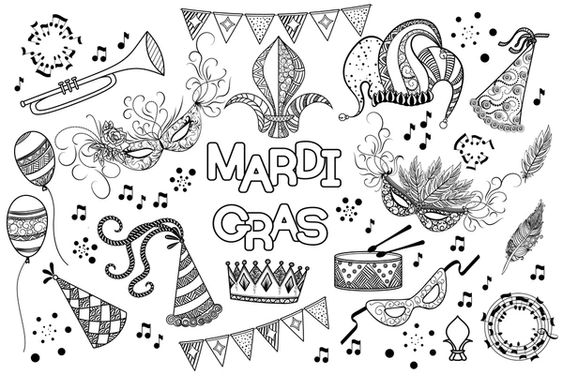 | Lunch is available Mon-Fri.  Orders need to be placed by 10:30am on the previous business day.  Suggested donation for meals is $4.50

