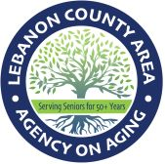
AGING INSPIRED
Join Aging Inspired to learn more about Aging Services and Supports in Lebanon County!
First Tuesday of the Month, 8:30 AM- VIRTUAL
January 6th, 2026- Sarah Conville-Is Your Home an Asset or an Anchor: Helpful tips about aging in place versus relocating to a care community.
February 3rd, 2026 Susan Blouch-Lebanon Rescue Mission
March 3rd, 2026 Bryan Smith-Lebanon County Christian Ministries
April 7th, 2026 Stacy Frey- Ennoble Care
May 5th, 2026
June 2nd, 2026
July 7th, 2026
August 4th, 2026
September 1st, 2026
October 6th, 2026
November 3rd, 2026
December 1st, 2026 Dementia Task Force- In person meeting at Lebanon County AAA- Co-Chairs, Lori Klein, Penns State Extension Office & Adrian Layser, Administrator- LCAAA.

